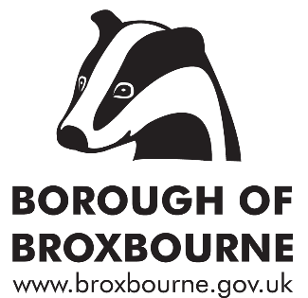
MENTAL HEALTH GRANTS 2023

Deadline for applications: Sunday 24 Sept 2023

Details

£40,000 has been set aside by Broxbourne Borough Council to spend on mental health and wellbeing projects to help offset the ongoing effects of the COVID-19 pandemic and the cost of living crisis. All expenditure is to be within the Borough of Broxbourne and to be spent / committed by 31 March 2023.

Applications are invited from local groups and organisations, whether statutory, non-statutory, community or voluntary sector, to apply for grants. There are no upper or lower limits for grants but the Council is looking to fund six or seven projects from the total £40,000.

The funding can be spent either on capital projects, e.g. building a shed, or on running costs/revenue, e.g. staff costs, utility or venue hire costs.

£10,000 of this sum has been earmarked to be spent on mental health and wellbeing initiatives to specifically support residents who are more likely to be disadvantaged or less likely to access mental health support, on grounds of:

- Minority ethnic origin;
- Disability
- Low income;
- Age – children, young people, older people.

For this £10,000 reserved for potentially disadvantaged Broxbourne residents, grant bids for new projects are welcome, because these residents have been underserved in the past. Projects to help micro-organisations increase their reach and impact are particularly welcome.

For the remaining £30,000 there is a strong preference for bids to expand projects that area already in operation somewhere in the Borough of Broxbourne or in Hertfordshire. The Council would particularly like to see initiatives already available to residents in one part of the Borough be made available elsewhere in the Borough e.g. delivering a similar session in Cheshunt as well as in Hoddesdon, as well as either general expansion or increase in capacity e.g. increasing the number of days that a project is open.

The funding must be spent in 2023/24. Preference will be given to bids that can demonstrate a legacy of increased service provision that lasts after the funding ends in March 2024.

Making an application

Please add your answers to the questions overleaf. Send your completed application to judith.ingham@broxbourne.gov.uk . Judith is also the contact point for any queries; tel. 01992 785572. The deadline is Sunday 24 Sept 2023.

Applications will be considered independently, then by a panel, and all being well, BACS payments will be made to successful applicant groups on 6 October 2023.

MENTAL HEALTH GRANTS APPLICATION FORM

Name and address of organisation to which grant will be paid:

Email address and phone number of a contact person who can answer questions about the bid:

Status of organisation: (Charity, statutory, social enterprise, group with articles of association etc.)

How much money are you asking for? £

Describe the project, service or initiative that you want to fund and how it is helpful for mental health and wellbeing of participants:

Where will the project take place (including postcode)?

Is your project/service particularly aimed at a group or groups of residents who are potentially disadvantaged, for example due to disability, minority ethnic origin, age, low income? Yes/No [Delete as applicable]

If you answered Yes to the question above, please describe how your project/service will benefit this target group? [Skip this question if this is not applicable]

What will you deliver with the grant, that is not already happening? Please give detail about quantities. For example, new location two evenings a week, estimate of the extra number of people who will be helped, etc.

How will you ensure that the benefits from the grant for this service/project continue after the grant funding is spent?

Provide a simple cost breakdown of how you will spend your grant. [The total should be equal to the amount of grant you are asking for.]

Bank Account Details
Bank Account Name
Account Number
Sort-code
Bank e.g. Barclays, Nationwide

END

