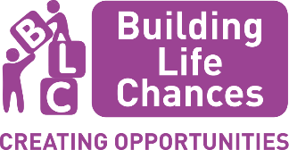

**Building Life Chances:**

**Application Guidelines for Early Years Small Grants Fund**

**Introduction to Building Life Chances Programme**

The Building Life Chances programme is a multi-agency programme addressing the impact of Covid-19 on those Hertfordshire residents already vulnerable, whose life chances have worsened during the pandemic.

The key themes for this programme were identified based on national and local evidence as well as discussions with partners, which identified the following priority areas to address pressing inequalities resulting from Covid-19:

* A good start in life
* Education and skills
* Food insecurity
* Health inequalities
* Financial and other support (including crisis support)
* Addressing inequalities

Projects have been developed around these themes, including the Early Years Small Grants Fund that falls within the Building Life Chances programme. Further information about this fund and how you can apply are detailed below.

**Guidelines and Criteria for** **the Early Years Small Grants**

These notes are for all applicants to the Building Life Chances Early Years Small Grants.

**Overview of the Early Years Small Grants Project**

Indications show that social development and school readiness of children under 5 has been significantly affected by the Covid 19 pandemic.

Research published by the Education Endowment Foundation, found that many children were struggling with their emotional well-being and vital aspects of early years development. The research also noted an increase in children who had separation anxiety. The research concluded that “For many children the experience of lockdown was made harder by cramped living conditions, no access to green spaces, parental mental health difficulties and financial hardship”.

Amanda Spielman, Ofsted’s chief inspector, commenting on four briefings on education recovery published by Ofsted, said the worst affected were the most vulnerable children, with those living in smaller homes without gardens typically spending more time on screens during successive lockdowns.

Narrowing the gap between our most disadvantaged children and other children is a priority.

**Funding Brief**

This grant seeks to support initiatives and ideas to help support the well-being, social development, and improve the school readiness of children under 5.

We expect a range of initiatives determined by the organisations working closely with and addressing the needs of the children in their communities, but examples could include story time furniture and/or materials to support language and numeracy skills; materials and equipment for a garden/wildlife area; introduction of mindfulness/meditation activities.

This grant will fund locally based organisations or groups for children aged 5 and under. Initiatives and ideas will be determined by providers who successfully apply for the funding.

**Grant criteria**

Your initiative must meet one of the following criteria: -

* Support the wellbeing of children under 5
* Support social development of children under 5
* Improve school readiness of children under 5

Organisations should also offer partnership working or signposting to ensure that parents/carers and children gain the opportunity to support their social development and/or school readiness further and know where or who to go to if they are concerned, in trouble or want help.

Ideally, applicants will be organisations that are embedded within the local community with a proven track record of supporting families with a variety of needs and who understand the challenges of engaging families within their locality.

**Outcomes**

Family and Health Services Commissioning will award the services of local providers to support young people within their community. The activities will aim to meet the following Outcome Bees in line with the Children & Young People’s Plan 2021/26:

* Be Happy – ‘Helping children and young people to know themselves and celebrate success’.
* Be Healthy – “Helping children and young people to adopt healthy lifestyles, build their self-esteem and lead active lives.”
* Be Resilient – “Provide advice and information to help children and young people get the support they need as soon as they need it.”

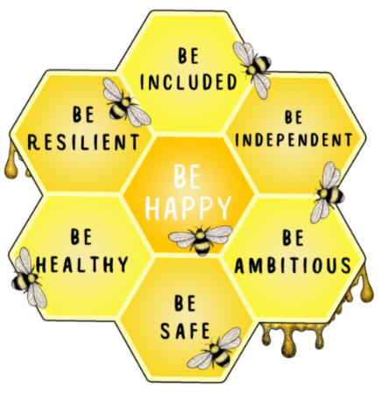

**Funding and applications for each grant**

Grants will be awarded for up to £2,500. This represents a **one-off** funding opportunity.

* Established organisations will be able to apply for this funding by way of a grant to enable them to deliver initiatives that meet the above criteria. The process is established by Family and Health Services Commissioning to facilitate applications.
* Applications will be considered by a panel of the Building Life Chances management team and Early Help colleagues.
* Successful applications will be monitored in line with the service specification to ensure value for money and that outcomes have been met.
* Grant money for successful bids will be paid within 28 days on receipt of an invoice and signed grant award letter.

**Application Process**

**Who can apply?**

This fund is open to all locally based organisations or children’s groups, Private, Voluntary & Independent (PVI) Early Years Settings, including organisations from the voluntary, community, faith, and social enterprise (VCFSE) sector.

**When to apply?**

Wednesday 21st June 2023

**How to apply?**

To apply for the grant, organisations need to complete the attached application form, providing as much information as possible.

Please be aware that all boxes of the application form need to have an entry in them, even if that is ‘not applicable’ or ‘none.’ This ensures that the awarding manager is sure that all questions have been read and considered.

Completed applications must be emailed to buildinglifechances@hertfordshire.gov.uk no later than 11:59 pm on Wednesday 12th July 2023.

**Applications sent to any other email address, by any other means or after the closing date will not be considered.**

**How decisions will be made**

Once all applications have been received, members of the Building Life Chances Programme Management team will complete due diligence checks on all applications to ensure the applications are complete and all required information is included. Any applications deemed not to be complete will be withdrawn from the process. Following this, a panel of the Building Life Chances Programme Management Team and Early Help colleagues will evaluate each application on its merits and make the final awarding decisions.

Organisations will then be contacted via email by a member of the Building Life Chances Programme Management team who will inform you of the final decision and the next steps, this will include the signing of a contract, before any money can be released.

**Timescales for the application**

* Grant application process opens Wednesday 21st June 2023
* Closing Date for applications Wednesday 12th July 2023
* Decision Notification – Monday 17th July 2023
* Project delivery end – Sunday 31st December 2023
* Final evaluation of project – Wednesday 31st January 2024

**Required Reporting**

The Building Life Chances Programme Manager will expect a brief evaluation report; a template for the report will be provided. The report should summarise:

* What has been delivered.
* Why this has been delivered, how does this reflect the need within the community.
* The Building Life Chances grant is a one-time grant. If the project is going to continue, please explain how you are going to sustain it once the grant money ends?

Reports should also include a breakdown of measurables, consisting of:

* How many children under 5 have accessed or benefitted from the initiative?
* What the funds have been spent on e.g.: venue, staffing, additional resources etc.
* How have you met the outcome bees?

**Safeguarding and Health and Safety Evidence**

We want every activity to be a safe and happy place for children to be and for parents, carers, and families to feel confident that their child is well looked after and that robust safeguarding arrangements are in place. Safeguarding and child protection is everyone’s responsibility. It is mandatory that all staff or volunteers working with Children have a up to date DBS certificate.

Hertfordshire County Council reserves the right to ensure this is in place at any point of the funding period.

You will need to provide a copy of your registration certificate as part of your application. Digital scanned copies are acceptable.

Applicants will need to be able to produce evidence of safeguarding procedures and insurance policies which you have in place for the activity planned if requested by Hertfordshire County Council.